Feature Engineering Project Proposal

**VEHICLE-RESALE VALUE PREDICTION**

Lokesh Punati, 11514358

Venkata Nagasai Kesani - 11553932

Rahul Mandaloju - 11514828

**Introduction**

Artificial Intelligence is a way of making a computer, a computer-controlled robot, or a software think intelligently, in the similar manner the intelligent humans think. AI is accomplished by studying how the human brain thinks and how humans learn, decide, and work while trying to solve a problem, and then using the outcomes of this study as a basis of developing intelligent software and systems.

Machine Learning may be defined as the field of computer science, more specifically an application of artificial intelligence, which provides computer systems the ability to learn with data and improve from experience without being explicitly programmed.

**Goals and Motivation**

Vehicle makers face several challenges in the second-hand market. The depth crisis in the European Union, the general problem of overcapacity, increasing competition from Asian manufacturers, and the trend toward more eco-friendly cars are only a few factors that add to the difficulty of selling used vehicles in the second-hand market and decrease sales margins. Therefore, Vehicle makers require sophisticated decision support systems to sustain the profitability of the used vehicle business. A core component of such systems is a prediction model that estimates resale prices on the basis of vehicle attributes .Although a statistical modeling of resale prices has been considered in previous work (e.g., Purohit, 1992), only very few studies have explicitly attempted to predict resale prices with maximal accuracy to support decision making. As a consequence, we don’t know to which degree resale prices are predictable, what is the relative accuracy of different prediction methods and are some methods particularly effective.

**Objectives**

* The main objective of vehicle-resale prediction models is to determine the resale value of a second-hand vehicle by considering vehicle attributes.
* This Model is very much useful for vehicle makers in the second-hand market by predicting the resale value of the vehicle.

**Literature Survey**

On doing the literature survey of various methods for vehicle-resale value prediction, we come to the conclusion that to predict the resale value there are multiple approaches like

* Multi-Linear Regression
* Decision Tree Regression
* Random Forest Regression

**Expected Output**

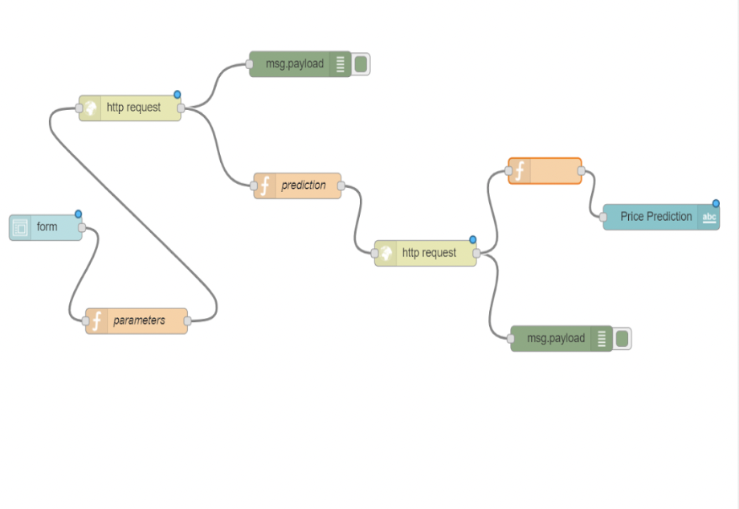

**Features and Statistical Techniques**

Data visualization is an important skill in applied statistics and machine learning. Statistics does indeed focus on quantitative descriptions and estimations of data. Data visualization provides an important suite of tools for gaining a qualitative understanding. This can be helpful when exploring and getting to know a dataset and can help with identifying patterns, corrupt data, outliers, and much more. With a little domain knowledge, data visualizations can be used to express and demonstrate key relationships in plots and charts that are more visceral to yourself and stakeholders than measures of association or significance

**REFERENCES**

<https://www.kaggle.com/ddmngml/trying-to-predict-used-car-value/data>

<https://www.geeksforgeeks.org/python-decision-tree-regression-using-sklearn/>

<https://scikit-learn.org/stable/modules/generated/sklearn.ensemble.RandomForestRegressor.html>

<https://www.datascience.com/blog/classification-random-forests-in-python>